

Cleveland State Cougar Classic

Speech & Debate Tournament

October 17 & 18, 2025

Dear Colleagues:

Cleveland State Community College proudly invites you to attend the 5th annual Cleveland State Cougar Classic Speech and Debate Tournament on October 17th & 18th, 2025. The tournament will feature competition in 11 AFA individual events plus radio broadcasting, individual IPDA, and NPDA. The IPDA debate will offer novice and open divisions with 6 preliminary rounds and an appropriate number of elimination rounds. NPDA will offer novice and open divisions (if possible) with 4 preliminary rounds and the appropriate number of elimination rounds.

The entry deadline is Monday, October 13th, 2025 by 5:00 p.m. via Speechwire. Fees must be paid upon arrival at the registration table, via cash or check (payable to CSCC/CSCC Debate Team).Awards will include:

**Sweeps Awards:**

* Awards for the top three 4-year and 2-year schools in I.E.
* Awards for the top three 4-year and 2-year schools in NPDA debate
* Awards for the top three 4-year and 2-year schools in IPDA debate
* Grand Champion sweepstakes award

**Individual I.E. Awards**

* Pentathlon awards for the top six competitors entered in at least five I.E. events
* Awards for the top six competitors in I.E. events
* Awards for the top novice in each I.E. event

**NPDA Debate Awards:**

* Awards for the top six speakers in open and novice
* Awards for debate elims through semis

**IPDA Debate Awards:**

* Awards for the top six speakers in open and novice
* Awards for debate elims through semis

I have included directions to our campus, a campus map, a schedule of events, event information and rules, lodging suggestions, and entry fee information and registration materials. Please contact me if you have any questions or concerns.

Cordially,

**Ms. Laurie Rowland Ms. Angela Ruiz**

*Chair of Humanities Dept., Assoc. Professor of Communication, Speech & Debate Asst. Director*

*Speech & Debate Director/Coach*

**Ms. Katie Rockhill & Mr. Caleb Spires** *Assistant Coaches*

Cleveland State Community College  
3535 Adkisson Drive | Cleveland, TN 37320

Cleveland campus Office [423-473-2333](tel:(423)%20473-2333) | [http://www.clevelandstatecc.edu](http://www.clevelandstatecc.edu/)

# Directions to Cleveland State Community College

**From 75 South:**

Take Paul Huff Parkway/Cleveland Exit 27, take a right at the end of the exit onto Paul Huff Parkway. At first red light, turn left onto Adkisson Dr. Continue 1 mile and Cleveland State Community College will be on the right. Please park in the lots circled in purple.

**From 75 North:**

Take Paul Huff Parkway/Cleveland Exit 27, take a left at the end of the exit onto Paul Huff Parkway. At first red light, turn left onto Adkisson Dr. Continue 1 mile and Cleveland State Community College will be on the right. Parking is open.

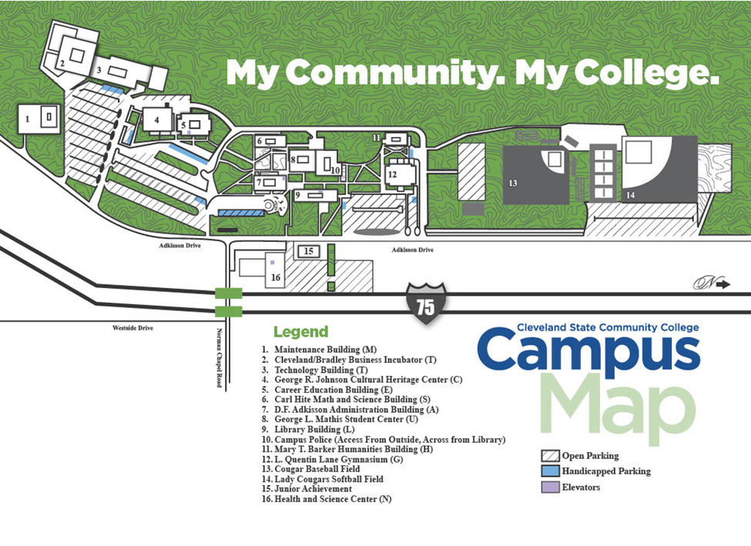

***We will be meeting in the George L. Mathis Student Center building (#8, near the center of the map).***

**Lodging**

Courtyard by Marriott (new hotel): 4385 Frontage Rd NW, Cleveland, TN 37312 (423) 250-5661

TRU by Hilton (new hotel): 4392 Frontage Rd NW, Cleveland, TN 37312 (423) 819-8400

Fairfield Inn & Suites by Marriott: 2815 Westside Dr NW, Cleveland, TN 37312 (423) 664-2501

La Quinta Inn & Suites: 130 Interstate Dr NW, Cleveland, TN 37312 (423) 813-7300

Wingate by Wyndham: 110 Interstate Dr NW, Cleveland, TN 37312 (423) 478-1212

Comfort Inn & Suites: 107 Interstate Dr NW, Cleveland, TN 37312 (423) 339-1000

Holiday Inn Express & Suites: 4355 Holiday Inn Express Way Northwest, Cleveland, TN 37312 (423) 790-1199

Hampton Inn: 4355 Frontage Rd NW, Cleveland, TN 37312 (423) 458-1222

TownePlace Suites by Marriott: 160 Bernham Dr NW, Cleveland, TN 37312 (423) 716-6737

**Food During the Tournament**

We plan to offer continental breakfast and lunch on Friday and Saturday in addition to an assortment of snacks throughout both days. Meals are included in a $10 per person fee (this includes breakfast, lunch, and snacks). As the schedule is tight, please consider staying on-campus to avoid the hassle of waiting for teams to return. Please note the number of vegetarians/gluten free on the entry form so that we can provide enough options for all.

**Individual Event Patterns**

**Flight A Flight B**

ADS DI

DUO EXT

IMP PER

INF POI

PRO POE

RADIO BROADCASTING CA/RC

**Entry Limitations for IPDA, NPDA, and IEs**

* IPDA debaters may NOT enter any IE events.
* NPDA debaters may NOT enter any IE events.
* All students must sign into rounds before competing to ensure being adjudicated.

**Special Notes**

**General Rules**

* We are NOT using the Flex time schedule for NPDA. There will be no cross examination between speeches and no extra prep time during round.
* We are on a strict time schedule, so if the judging sheets from the previous round are in the Tab Room, the topic announcement will happen on schedule, and it is your team's responsibility to have someone in there to hear the announcement.
* The Tab Room is closed to coaches, judges, and competitors.
* AI- Artificial Intelligence: This tournament is taking a neutral position on using AI. HOWEVER, we ask that you disclose if you are using it to your competitors and judges.
* We WILL NOT break brackets.
* All fees must be paid before competition unless otherwise approved by me before the week of the tournament.
* If you need fee assistance, please let me know before the tournament, and I will work with you & your team.
* I will drop any school the morning of with no payment & no prior contact, and will send an invoice for the fines for late drop.

We believe these rules will promote fairness, timeliness, and encourage the rigor that is forensics competition.

**Internet Access**

Competitors will be allowed to use the Internet during their preparation time. CSCC has guest Wi-Fi access available in most areas. However, a perfect Wi-Fi connection is not guaranteed. Access to electrical outlets will be limited.

**Tournament Observers**

Some CSCC instructors may encourage their students to observe rounds. The faculty have been informed that they should discuss proper audience etiquette with their students prior to attending the event.

**Entry Fees for the CSCC Forensics Classic Tournament**

Covered Individual Event Entries    $12.00

Covered NPDA Debate Entries                    $60.00

Covered IPDA Debate Entries $30.00

Uncovered Individual Event Entries              $12.00 (plus entry)

Uncovered NPDA Debate Entries                                                $60.00 (plus entry)

Uncovered IPDA Debate Entries $30.00 (plus entry)

IE Drops between Tuesday 10/7 & Thursday 10/9              $12.00 (per entry)

IE Drops at Registration                                                                $20.00 (per entry)

Dropped IE Judges between Tuesday 10/7 & Thursday 10/9        $12.00 (plus uncovered fee per entry to be covered)

Dropped IE Judges at registration                                                          $12.00 (plus uncovered fee per entry to be covered)

NDPA Debate Team Drops between Tuesday 10/7 & Thursday 10/9    $60.00 (plus entry fee per team)

NDPA Debate Team Drops at Registration                                              $80.00 (plus entry fee per team)

Dropped Debate Judges  between Friday 10/7 & Thursday 10/9  $60.00 (plus uncovered fee per entry to be covered)

Dropped Debate Judges at registration                                                  $80.00 (plus uncovered fee per entry to be covered)

IDPA Debate Team Drops between Tuesday 10/7 & Thursday 10/9    $30.00 (plus entry fee per team)

IDPA Debate Team Drops at Registration                                              $50.00 (plus entry fee per team)

Dropped Debate Judges  between Friday 10/7 & Thursday 10/9  $30.00 (plus uncovered fee per entry to be covered)

Dropped Debate Judges at registration                                                  $50.00 (plus uncovered fee per entry to be covered)

Meal Fee $5.00 per competitor/per day

**Judge Options:**

One judge will cover six individual event entries or two debate entries.

**CSCC Forensics Classic Flights and Event Rules**

**Flight A Flight B**

**ADS DI**

**DUO EXT**

**IMP PER**

**INF POI**

**PRO POE**

**RADIO BROADCASTING RC**

PATTERN A EVENT RULES

Radio Broadcasting:

In this event, each student will receive a packet of news-copy or a newspaper. The student will report to a preparation room where s/he will have 30 minutes to select and organize the material into a 5 minute radio news broadcast. Judges will listen to (not watch) the presentation. Throughout the broadcast, the timekeeper or judge will keep the student informed of time. Students may use their own introductory remarks and transitional material, but they may not introduce advertisements, fillers or any other material that is not present in the copy provided by the tournament staff.

Time: 5 minutes; 5 second grace over or under time.

After Dinner [ADS]:

A speech designed to entertain the audience. This should not be a series of jokes, but should emphasize wit and creativity while following a central theme. It may be done with/without notes.

Maximum time limit: 10 minutes

Prose [PRO]:

Program may consist of single or multiple selections around a central theme. Manuscripts are to be used. Introduction and transitions should be delivered extemporaneously. Plays are not permitted. Maximum time limit: 10 minutes.

Impromptu [IMP]:

For this event, each student will receive the same topic. 7 minutes is allocated for preparation and speaking time, of which at least three minutes must be devoted to speaking. All contestants in a section will address the same quotation.

Informative [INF]:

An original, factual speech on a realistic subject to fulfill the general goal of informing the audience. Research should be involved -- should not be simply personal experience or the retelling of a movie plot, etc. Visuals are permitted. Notes may be used.

Maximum speaking time: 10 minutes.

Duo Interpretation [DUO]:

A cutting (scene) from a play (either humorous or dramatic in tone) which involves the portrayal of two or more characters presented by two individuals. This is not an acting event and no costumes, props, lighting, etc. are to be used. Presentation is from the manuscript and the focus should be off-stage and not to each other. A contestant may enter two duos with different partners. Duo only counts once for Pentad competition.

Maximum time limit: 10 minutes. Time limit includes original introduction.

PATTERN B EVENT RULES

Extemporaneous Speaking [EXT]:

Topics will be from current events (foreign/domestic) since September 1, 2016. Contestants will choose one topic. There will be a half-hour preparation time before each speaking round. Notes may be used.

Maximum time limit: 7 minutes.

Poetry [POE]:

Program may consist of single or multiple selections around a central theme. Introductions and transitions should be delivered extemporaneously. Manuscripts are to be used.

Maximum time limit: 10 minutes.

Programmed Oral Interpretation [POI]:

A program of thematically linked selections of literary merit, chosen from two or more of the recognized genres of competitive interpretation (prose/poetry/drama).

Maximum time limit: 10 minutes. Total time includes original introductions and transitions.

Dramatic Interpretation [DI]:

A cutting from a play or plays of literary merit that may be humorous or serious. This involves the portrayal of one or more characters presented by one individual. This is not an acting event -- no costumes, props, lighting, etc. are to be used. Presentation is from the manuscript and the focus should be off-stage.

Maximum time limit: 10 minutes. Time limit includes original introduction.

Persuasion [PER]: The speech must be original and the product of the contestant’s own thinking. The speech must be persuasive in the broadest sense of the word. Notes may be used. Maximum time limit: 10 minutes.

Rhetorical Criticism (also known as Communication Analysis) [RC]: An original speech by the student designed to offer an explanation and/or evaluation of a communication event such as a speech, speaker, movement, poem, poster, film, campaign, etc., through the use of rhetorical principles. Audio-visual aids may or may not be used to supplement and reinforce the message. Manuscripts are permitted. Maximum time limit is 10 minutes.

**CSCC Forensics Classic Speech & Debate Tournament Schedule**

**Friday: IPDA** **Saturday: NPDA**

8:00am Registration (Student Center, main floor) 8:00 Registration (Student Center, main floor)

9:00 IPDA Topic Draw 8:45 NPDA Topic Announcement

9:30 IPDA Round 1 9:05 NPDA Round 1

10:15 IDPA Topic Draw 10:00 NPDA Topic Announcement

10:45 IPDA Round 2 10:20 NPDA Round 2

11:30 IDPA Topic Draw 11:15 NPDA Topic Announcement

noon IPDA Round 3 11:35 NPDA Round 3

12:30 Lunch (Student Center, main floor) 12:15 Lunch (Student Center, main floor)

1:30 IDPA Topic Draw 1:30 NPDA Topic Announcement

2:00 IPDA Round 4 1:50 NPDA Round 4

3:00 IPDA Topic Draw 3:00 NPDA Topic Announcement Quarterfinals

3:30 IPDA Round 5 3:20 NPDA Quarterfinals

4:30 IPDA Topic Draw 4:15 NPDA Topic Announcement Semifinals

5:00 IPDA Round 6 4:35 NPDA Semifinals

**Saturday IPDA**  5:40 NPDA Topic Announcement Finals

8:00 IDPA Topic Draw Octo-final 6:00 NPDA Finals

8:30 IPDA Octo final 7:30 Awards Ceremony (Johnson Theater)

9:30 IPDA Topic Draw Quarterfinals

10:00 IPDA Quarterfinals

**PLEASE NOTE:**

**All IPDA postings/draws will be in the Johnson Theater.**

**All NPDA postings/topic announce will be in the Health & Science Building Rm H125**

11:00 IPDA Topic Draw SemiFinals

11:30 IPDA Semi Finals

12:00 Lunch (Student Center, main floor)

1:00 IPDA Topic Draw Finals

1:30 IPDA Finals

7:30 Awards Ceremony (Johnson Theater)

**Saturday: IE**

7:30 IE Registration (Student Center, main floor)

8:00 Radio Draw (H-107)

Round 1 - Flight A

9:45 Extemp Draw (H-107)

Round 1 – Flight B

11:30 Radio Draw (H-107)

Round 2 – Flight A

12:00 Lunch (Student Center, main floor)

1:45 Extemp Draw (H-107)

Round 2 – Flight B

3:30 Radio Draw Finals (H-107)

Finals – Flight A

5:15 Extemp Draw Finals (H-107)

Finals – Flight B

7:30 Awards Ceremony (Johnson Theater)

**PLEASE NOTE: All IE postings will be in the Student Center**